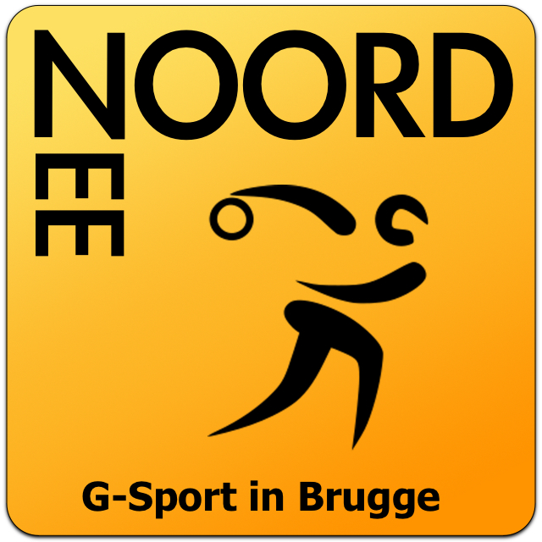 | Open West Flemish Cup Goalball 2017  Games schedule  26-27 August 2017  Bruges, Belgium

POULE A | POULE B
BELGIUM | FINLAND
CZECH REPUBLIC | GREAT BRITAIN
SLOVENIA | ITALY
NETHERLANDS | NOORDZEE
GREECE

26/08/17
 | ZAAL A |  | ZAAL B
10:00 | NETHERLANDS | BELGIUM | SLOVENIA | CZECH REPUBLIC
11:00 | FINLAND | NOORDZEE | GREAT BRITAIN | ITALY
12:00 | SLOVENIA | GREECE | CZECH REPUBLIC | BELGIUM
14:00 | CZECH REPUBLIC | NETHERLANDS | BELGIUM | GREECE
15:00 | NOORDZEE | GREAT BRITAIN | ITALY | FINLAND
16:00 | BELGIUM | SLOVENIA | NETHERLANDS | GREECE
17:00 | ITALY | NOORDZEE | GREAT BRITAIN | FINLAND
27/08/17
 | ZAAL A |  | ZAAL B
9:00 | GREECE | CZECH REPUBLIC | SLOVENIA | NETHERLANDS
10:30 | 1. 1/4 final (2e B - 3e A) |  | 2. 1/4 final (3e A - 2e B)
11:30 | 3. 1/4 final (1e B - 4e A) |  | 4. 1/4 final (1e A - 4e B)
13:00 | 1. place 5-8 (losers 1. 1/4 -4. 1/4) |  | 2. place 5-8 (losers 2. 1/4 - 3. 1/4)
14:00 | 1. 1/2 final (winner 1. 1/4 -3. 1/4) |  | 2. 1/2 final (winner 2. 1/4 - 4. 1/4)
15:00 | Winners of place 5-8 (rank 5-6) |  | Losers of place 5-8 (rank 7-8)
16:00 | Bronze medal game
17:00 | Gold medal game

